MongoDB Assignment 03

248518 Gaurav B Raskar.

Q.1.

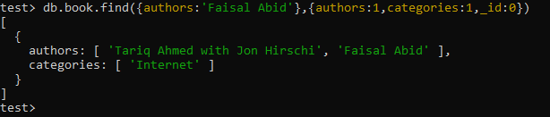

Q.2.

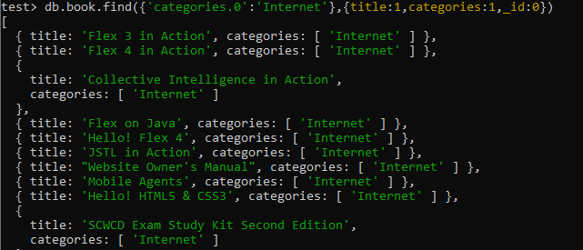

Q.3.